# 

**Introduction** **2**

Business Overview 2

Website Structure 3

Design Decisions and Challenges: 3

Design Decisions and Challenges 3

Design Decisions: 3

Challenges: 3

**AI Assistance Declaration** **4**

AI Tools Used: 4

Design Drafts: 4

Content Generation: 4

Comparisons: 4

AI-Generated Draft vs. Final Design: 4

**Accessibility and Usability** **4**

Accessibility Considerations: 4

Usability Considerations: 5

**Screenshots & Visual Progress:** **8**

Home page 8

About Page 9

Contact Page 11

Adopt Page 12

Initial Home page Prototype 13

Figma Prototype 14

**Reflection and Learning** **14**

Experience Reflection: 14

Iteration: 14

# Introduction

### Business Overview

Paws and Claws Rescue is a pet rescue and adoption organization that seeks to find animals in need of loving homes. Basically, the website would be the central location where available pets would be showcased to the public and also serve to explain the adoption process to them while briefly describing the mission and services of the organization. It would be structured in a user-friendly format, with major pages such as Home, About, Adopt, and Contact.

### Website Structure

* **Home Page**: The introductory hero section, promoted adoption section, and Testimonials that alternate with the embedded videos.
* **About Page**: Delve a bit deeper into the organization and FAQ accordion.
* **Adopt Page**: Contains pets available for adoption are listed in clear manner with image and their behavior.
* **Contact Page**: Contains contact form that with validation and alert on submit

### Design Decisions and Challenges:

The design needed to accommodate aesthetics and functionality, all while users would find the website intuitive. Some of the central challenges were keeping visual consistency throughout the different parts, making a responsive layout that would display well on different screen sizes, and adding interactivity with FAQ accordion and scroll-to-top button without altering performance. Efficient making of user accessibility or the engagement of the content was one of the great challenges.

### Design Decisions and Challenges

#### Design Decisions:

* The Navigation and User Experience:
  + Active Navigation Links: For the active navigation links, it should be informative with the appropriate color depending on the page. In general, this is crucial to indicate to users the specific location that they are in on the page.
  + Scroll-To-Top Button: A button was added that, when clicked, brought the user back up to the top of a long page. A scroll-to-top button enhances navigation since it leads you back to the top of a web page or UI without manual scrolling.
* Accordion:
  + Developed an accordion functionality for FAQs, which shows and collapses the answers. The idea is to save space, but at the same time, offer the information in an accessible way to the user.
* Form:
  + Responsive Forms Design and development of forms, which are accessible on devices, including proper labeling and validation.

#### Challenges:

* Accessibility has to been taken care:
  + Screen Reader Compatibility: If proper semantic HTML is paramount, it then becomes similarly paramount that ARIA roles are in place for screen reader compatibility. Interactive elements such as forms and accordions became quite a challenge to ensure they worked well.
  + Keyboard Navigation: Since proper testing and adjustment were done on the interactive elements, forms, and accordion buttons should now be totally keyboard-navigable.
* Responsive Design:
  + Same across all devices: It was a big challenge to ensure it looks and feels the same across all devices and screen sizes. Also, guaranteeing a translation of the layout and design elements, which are huge on desktop screens, to very small mobile devices, took the use of CSS media queries.
* Interactive Features:
  + Smooth Transitions in Accordions: It was not an easy task to build a responsive accordion feature with smooth transitions that did not blink to lose performance and accessibility. The demands of making the appearance visually attractive against usability caused multiple iterations and testing.
* Form Validation:
  + Internal Validation: Ensuring that forms validate in real-time to provide instant feedback and work on the maximum number of browsers and devices called for careful coding and vigorous testing.

# AI Assistance Declaration

### AI Tools Used:

#### Design Drafts:

AI tools were used to generate initial design drafts and layout suggestions. These drafts provided a starting point for further customization.

#### Content Generation:

AI was employed to generate initial text content for pages such as the "About" section and FAQs. This content was then reviewed and customized to fit the specific needs of the "Paws and Claws Rescue" website.

### Comparisons:

#### AI-Generated Draft vs. Final Design:

**Draft**: Basic layout and content with placeholder text.

**Final Design**: Customized content reflecting the organization's mission, with refined layout and visuals.

# Accessibility and Usability

### Accessibility Considerations:

**Semantic HTML:**

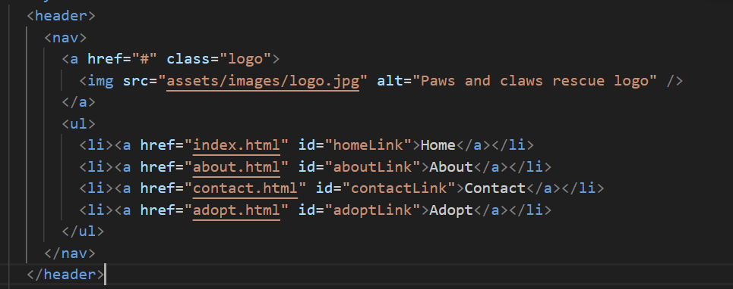

**Alt Text for Images:**

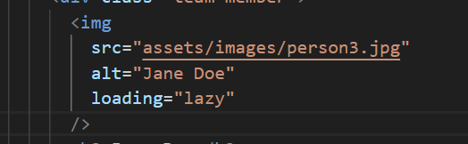

### Usability Considerations:

**Active Navigation Indicators:**

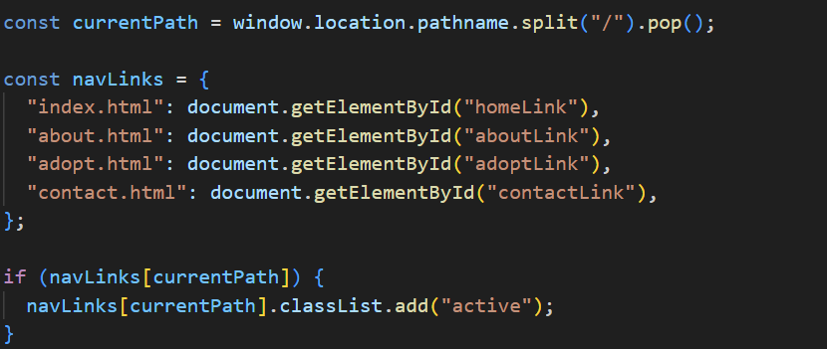

**Scroll-to-Top Button:**

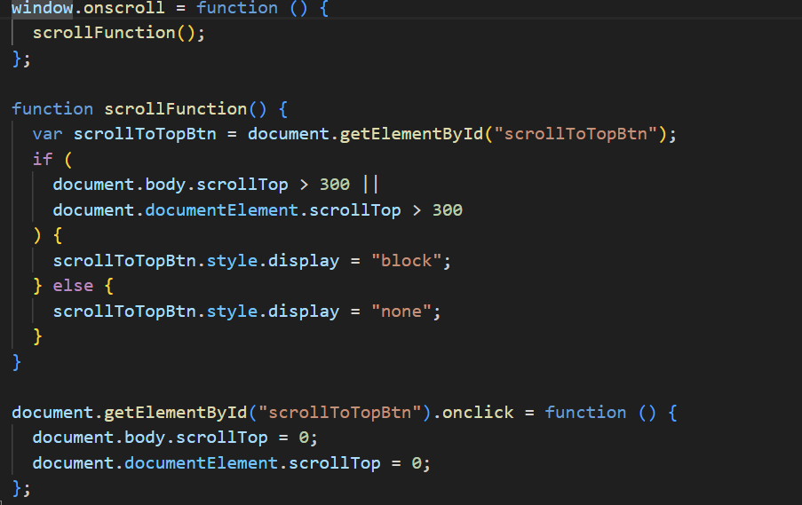

**FAQ Accordion:**

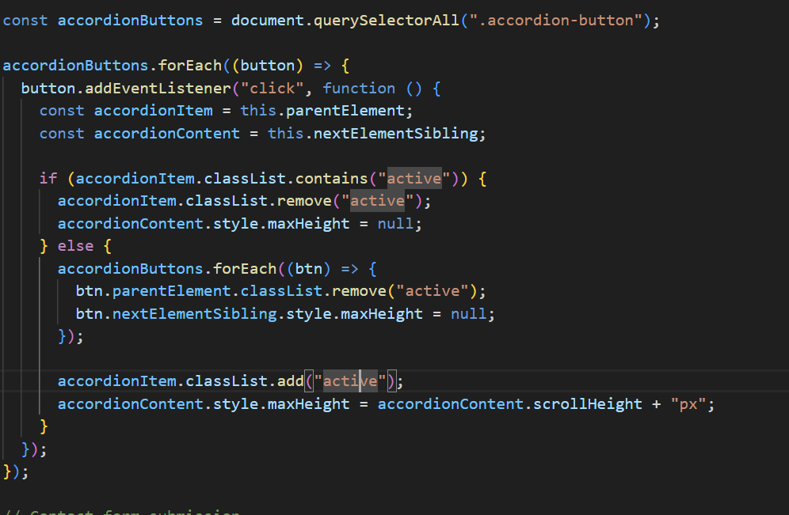

**Responsive design**

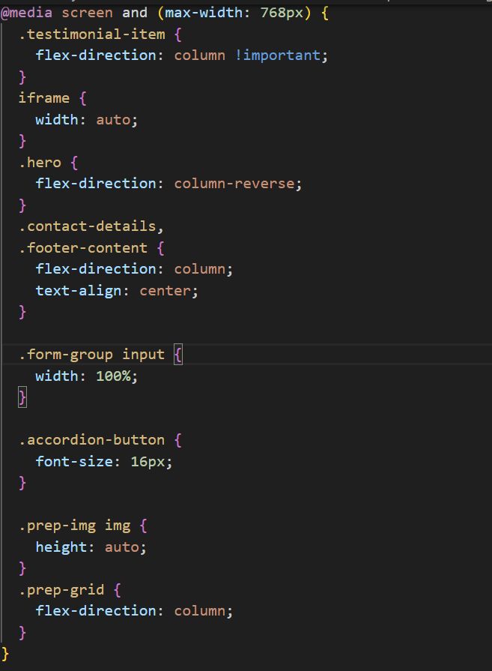

# Screenshots & Visual Progress:

### Home page

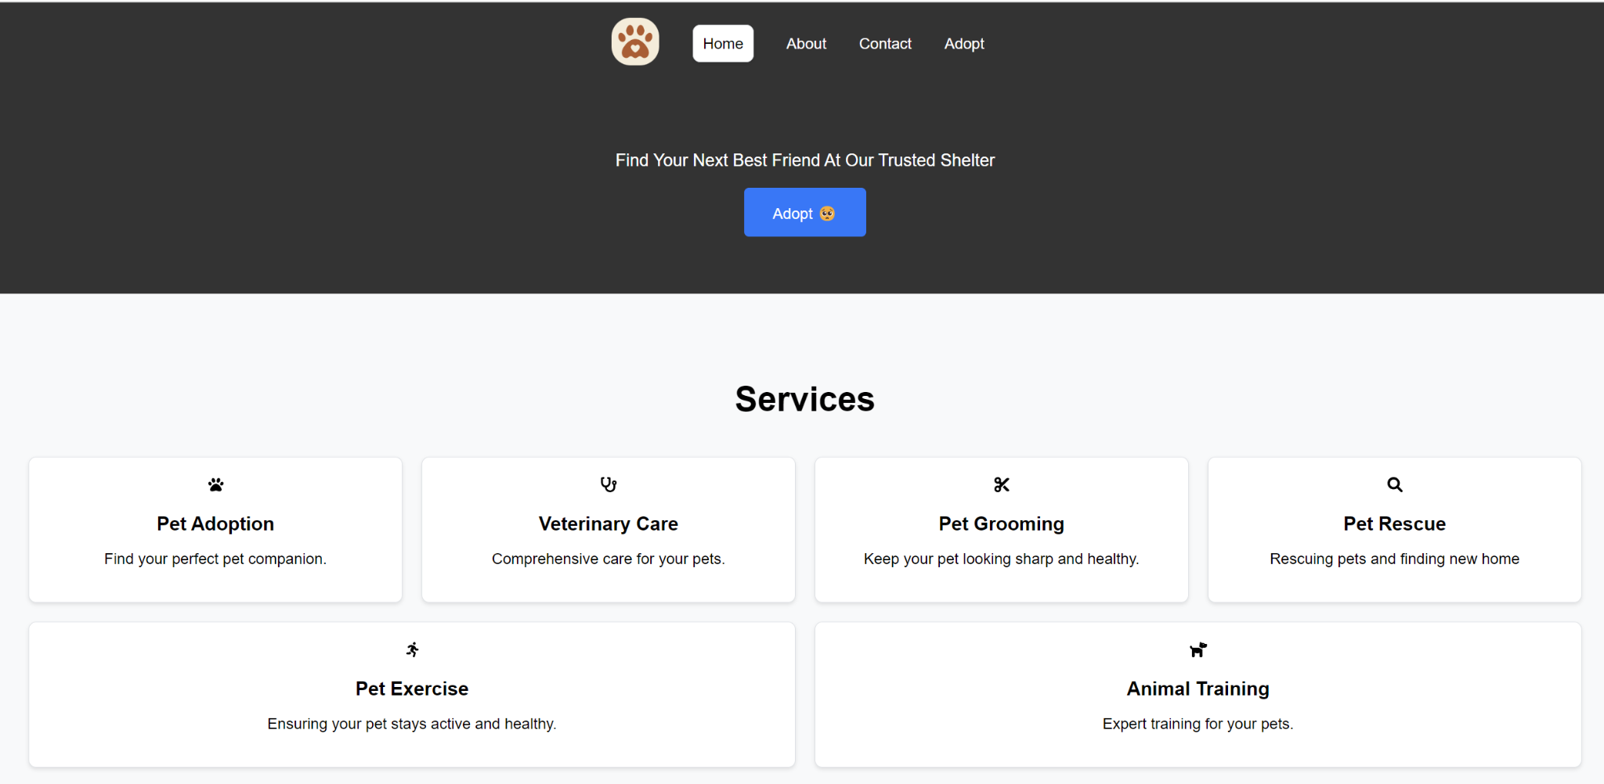

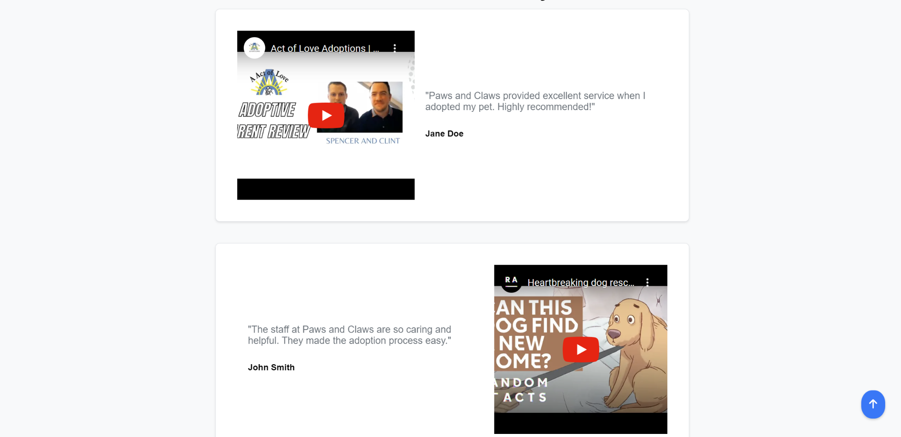

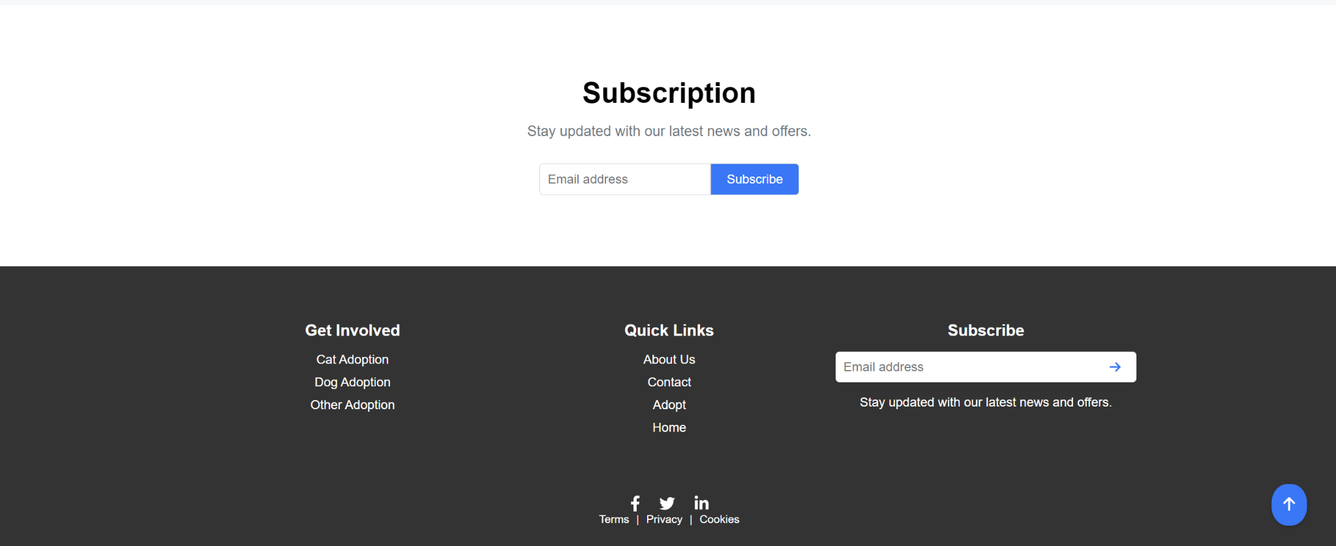

### About Page

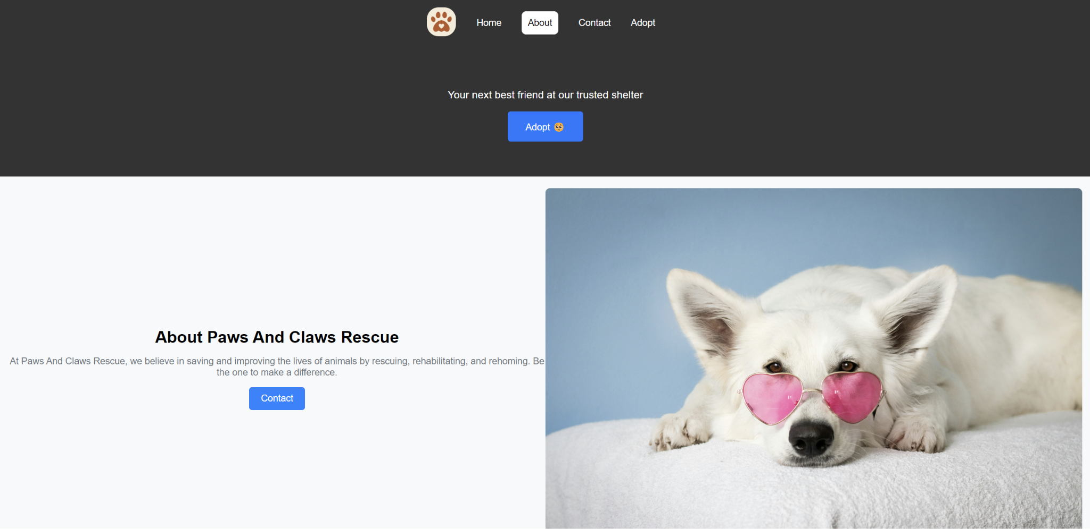

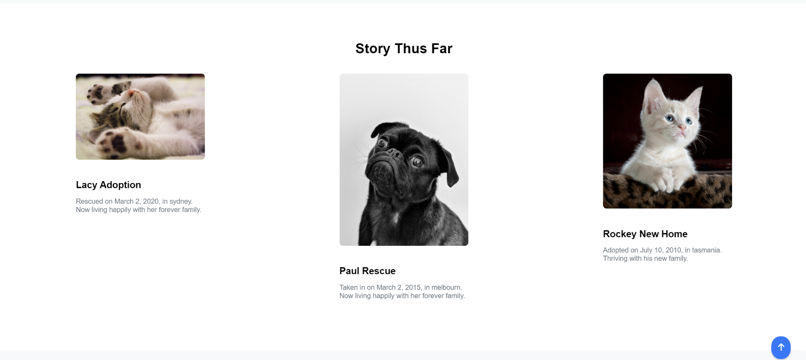

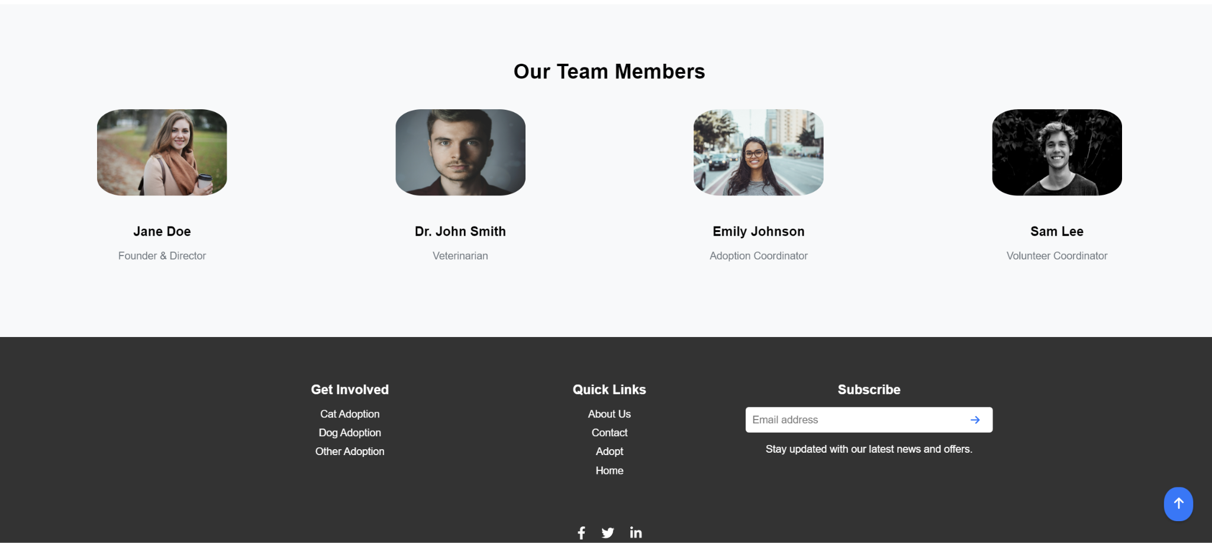

### Contact Page

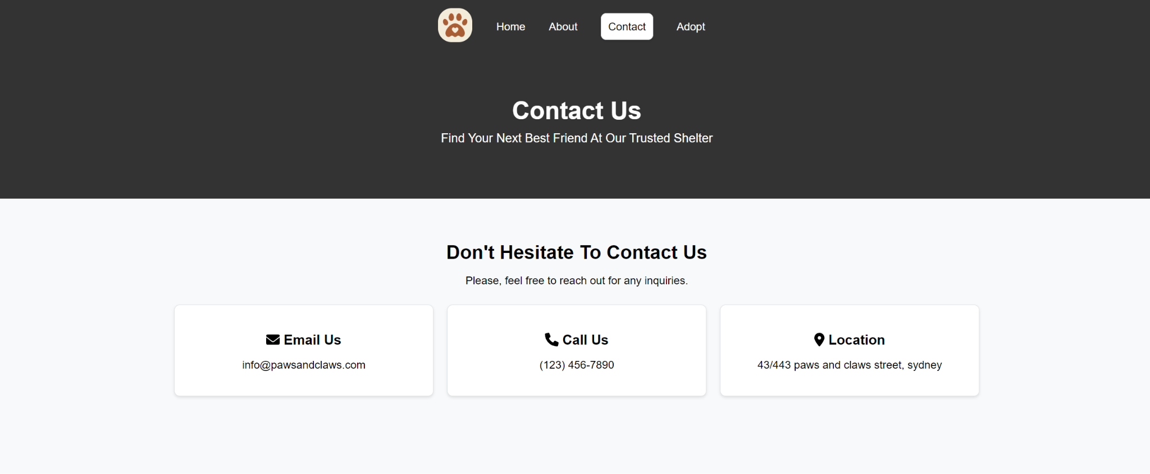

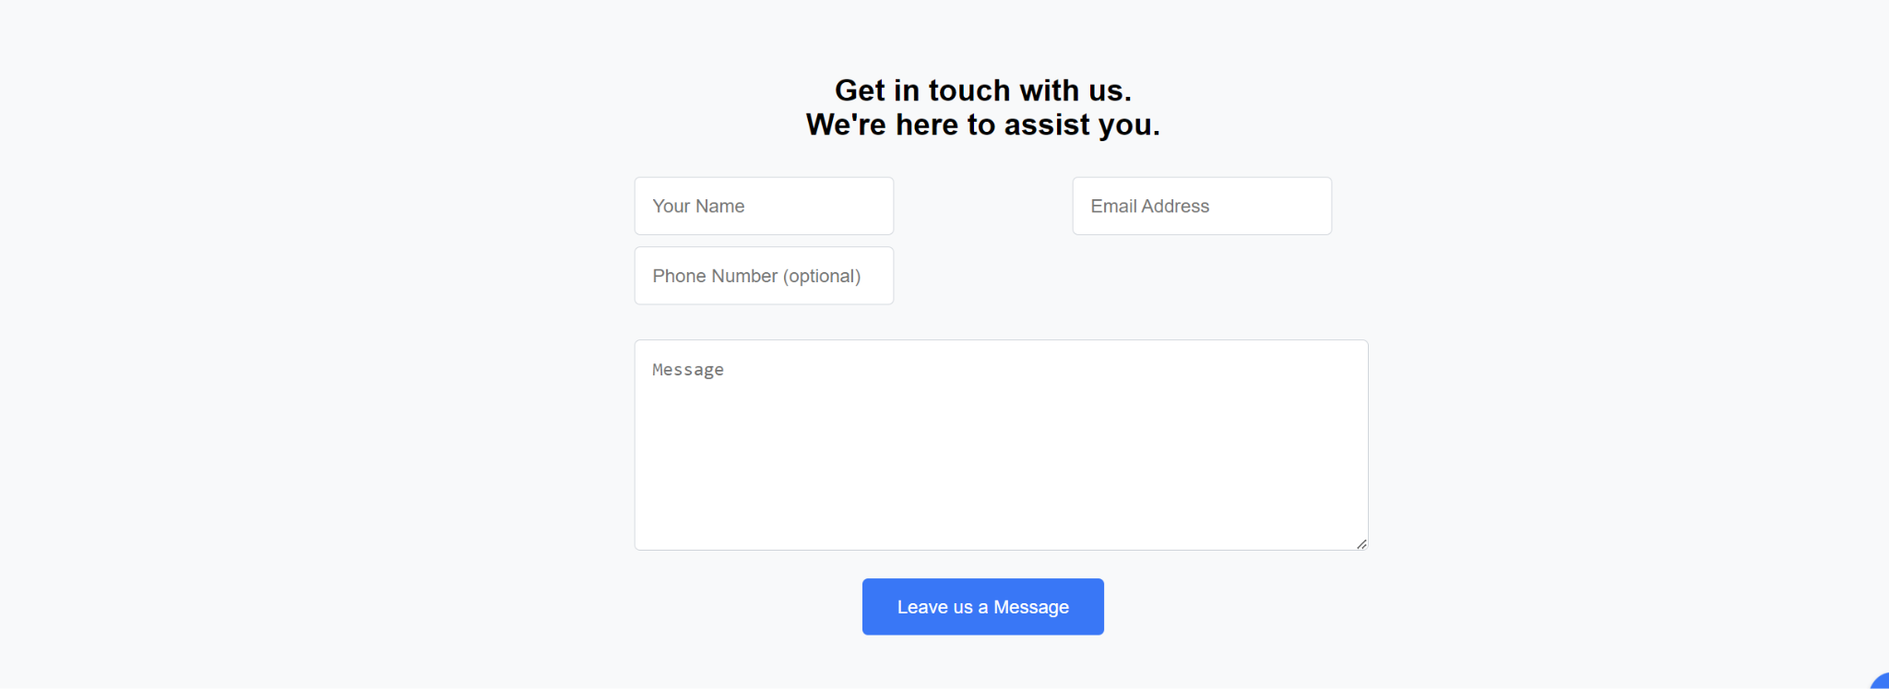

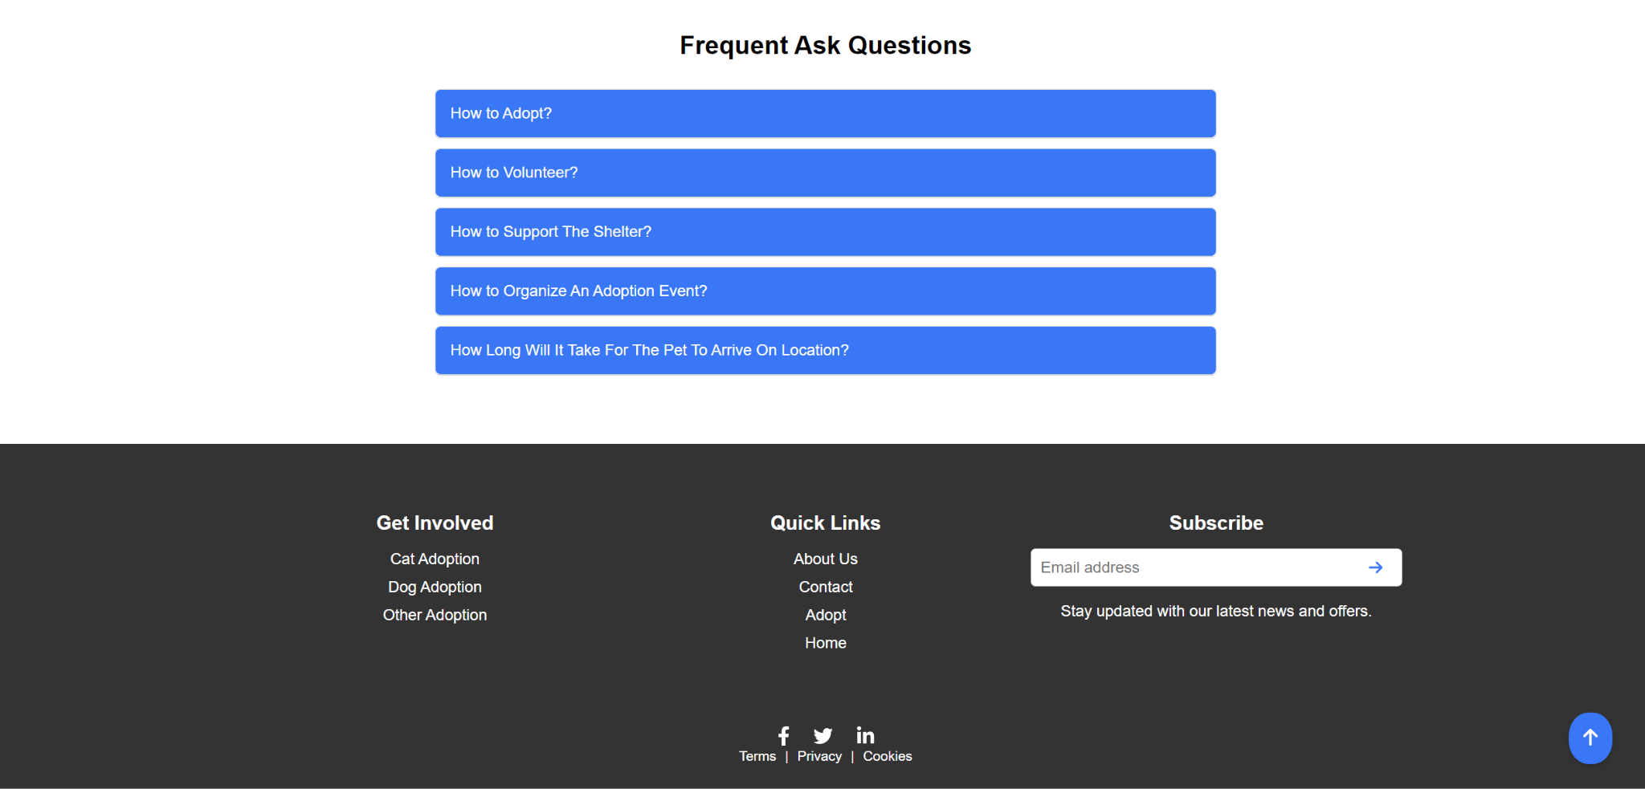

### Adopt Page

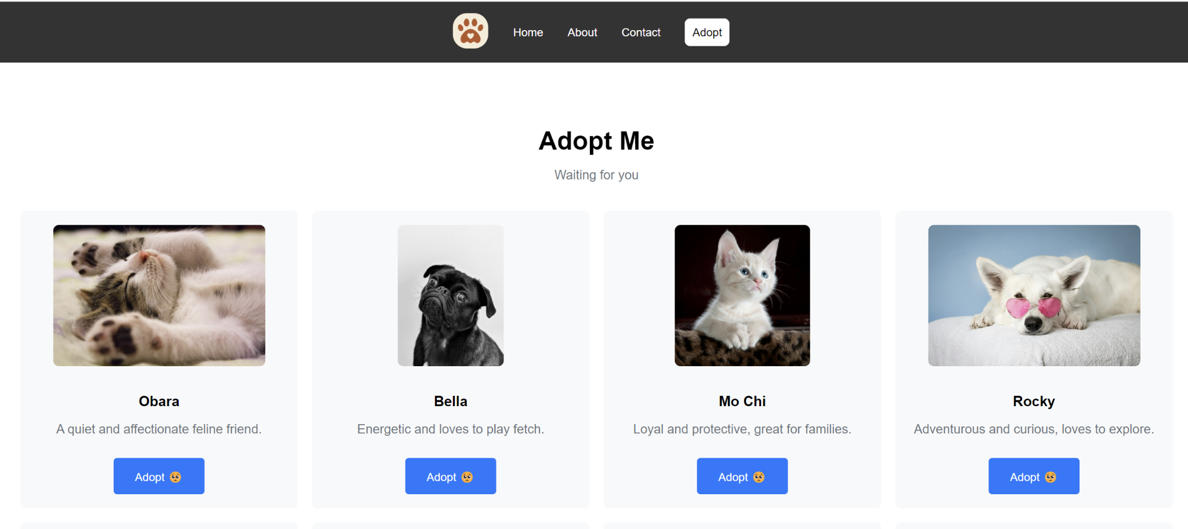

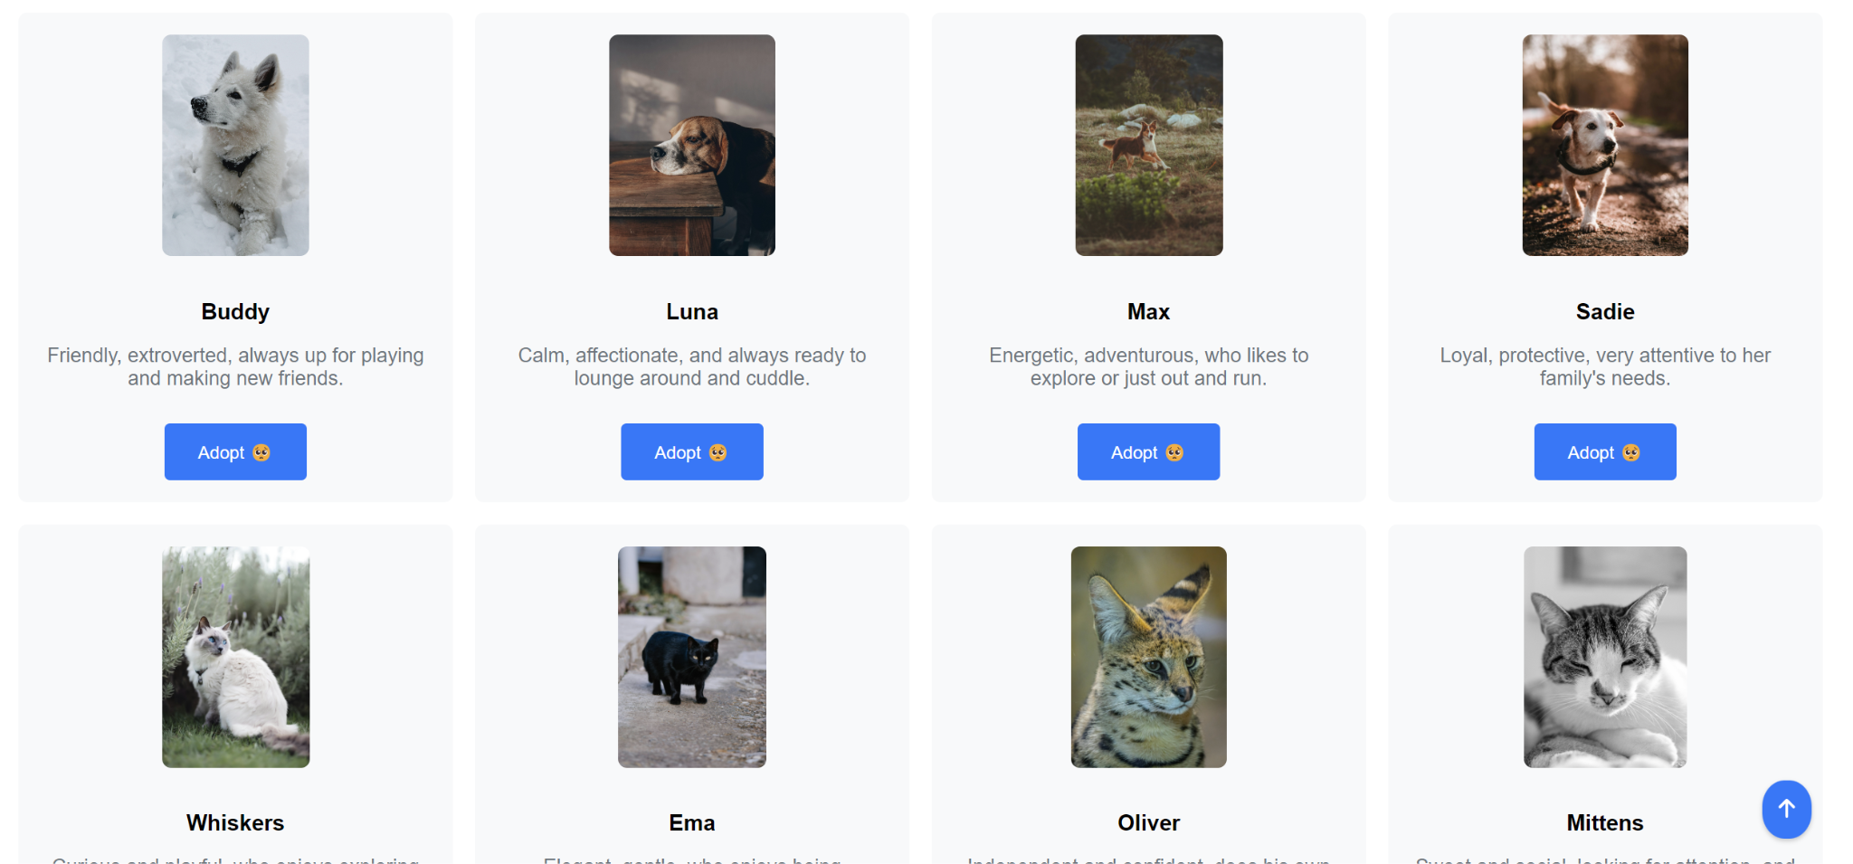



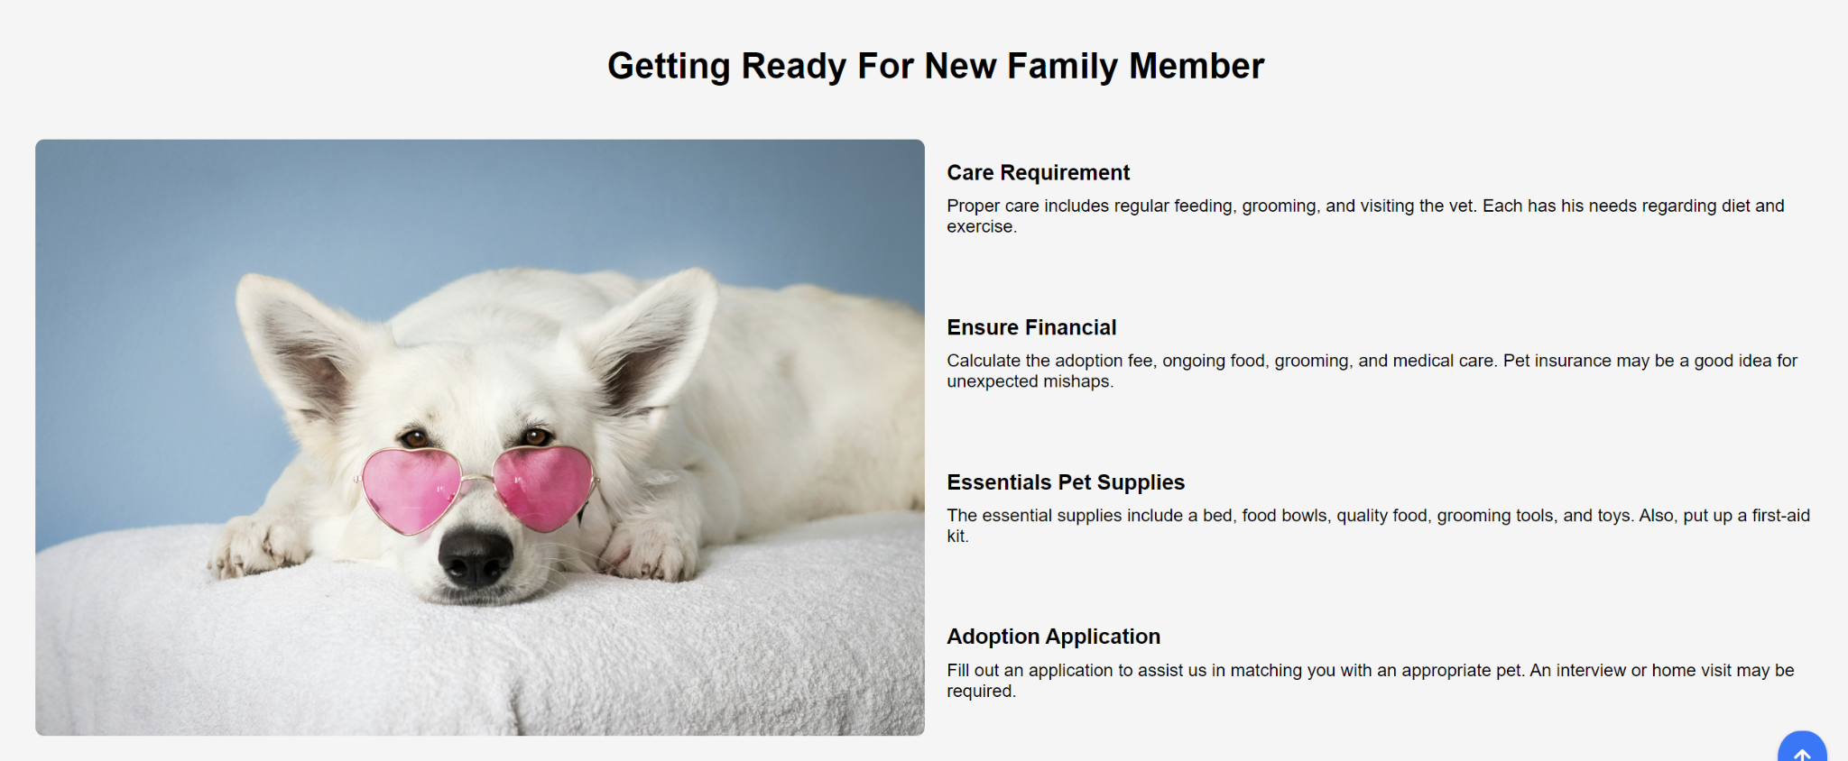

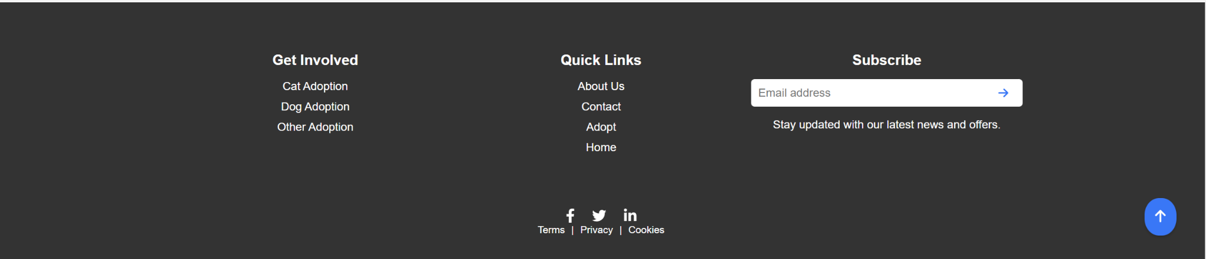

### Initial Home page Prototype

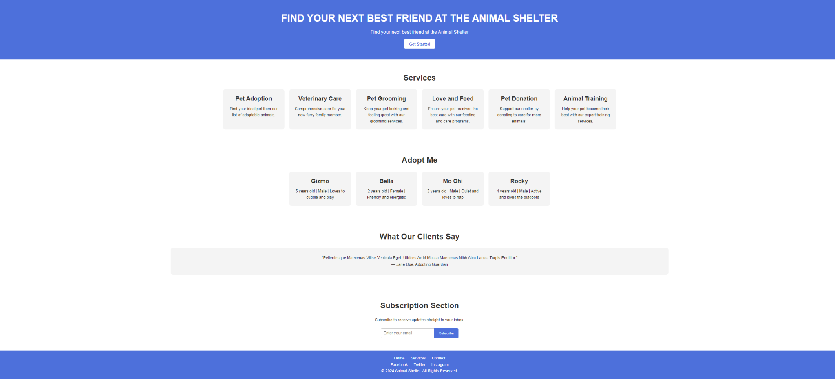

### Figma Prototype

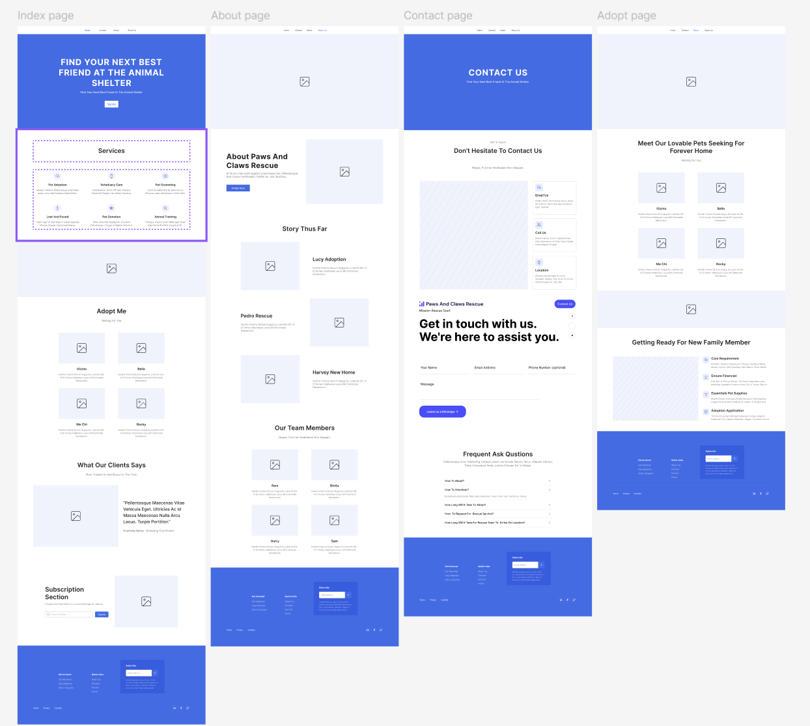

# Reflection and Learning

### Experience Reflection:

Designing the Paws and Claws Rescue website has been an enriching experience, teaching me some things about web design, accessibility, and user interaction. The challenge in putting interactive features into the site while making sure that it was accessible and responsive had a number of mishaps but also useful learning moments.

### Iteration:

In the process of development, iterations were done in order to make site interactive and accessible to improvise the website:

**Interactivity:** Ensuring that all interactive features, such as the accordion FAQ and scroll-to-top button, worked well and were accessible to every different kind of user.

**Responsive design:** Further tweaking of CSS and JavaScript was done to ensure that the website remained responsive across a large number of devices and various screen sizes.

**Accessibility Improvements:** Iterations included adding ARIA roles and improving keyboard navigation for making the website more accessible for screen reader users.

**Form usability:** Tidied up form validation and added user feedback for enhanced usability and performance.

**Prototype update:** Changes were made so the design looks more into the theme of business motto.

These incremental changes were user-centered and driven by iterative testing and feedback for maximum usability and accessibility of a website.

# Links

**Github:** [**https://github.com/AnilKumarKarki1/paws.git**](https://github.com/AnilKumarKarki1/paws.git)

**Drive:** [**https://drive.google.com/drive/folders/1yf7lyFptEzHB_9c7NX7i2Fg2QJSbcL6e?usp=drive_link**](https://drive.google.com/drive/folders/1yf7lyFptEzHB_9c7NX7i2Fg2QJSbcL6e?usp=drive_link)

Google drive contains images that goes inside of **assets/images**  folder

**Alternatively**Github link can be used to download all the project files